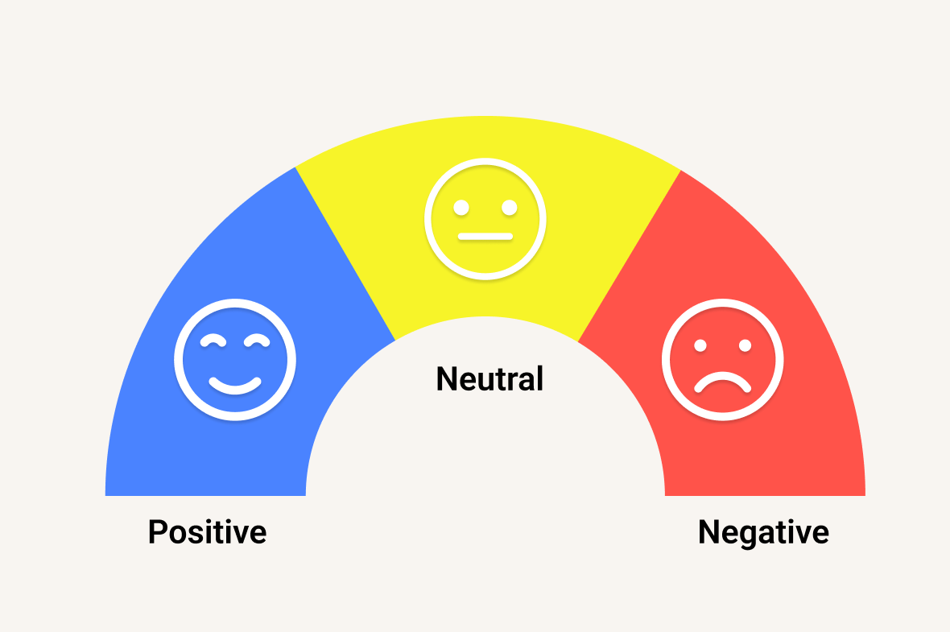

Social Media Sentiment Analysis (NLP Project)

PROJECT REPORT

By
GROUP 20
DATA ANALYST


INTRODUCTION
In the digital era, social media platforms have become one of the most influential sources of information and public expression. Millions of users share opinions, feedback, and experiences every day through comments, reviews, and posts. Analyzing this vast amount of unstructured textual data manually is difficult and time-consuming. Therefore, sentiment analysis plays a crucial role in understanding public opinion, emotions, and trends expressed through online content.
Sentiment analysis, also known as opinion mining, is a Natural Language Processing (NLP) technique used to identify and classify emotions expressed in text as positive, negative, or neutral. It is widely used in areas such as marketing, political analysis, customer feedback evaluation, and social media monitoring. By analyzing sentiments, organizations can gain valuable insights into user behavior, customer satisfaction, and public perception of products, services, or events.
In this project, social media comment data is collected and processed to perform sentiment analysis using text preprocessing techniques such as tokenization, stop-word removal, and normalization. The cleaned data is then analyzed using sentiment classification methods to determine the polarity of each comment. Furthermore, data visualization tools like Tableau are used to present the results through interactive dashboards, including sentiment distribution, trend analysis over time, and word cloud visualizations.
This project demonstrates how data analytics and visualization techniques can be effectively combined to transform raw textual data into meaningful insights, supporting better decision-making and understanding of user opinions in the digital environment.

ABSTRACT
Social media platforms generate a massive volume of user-generated content every day, making sentiment analysis an essential tool for understanding public opinion. This project focuses on analyzing user comments collected from online platforms to determine public sentiment using data analytics techniques. The dataset consists of comment text, user details, engagement metrics, and timestamps.
The data is first preprocessed through cleaning, tokenization, and removal of irrelevant information to ensure accuracy. Sentiment analysis is then performed to classify comments into Positive, Negative, and Neutral categories using text-based sentiment scoring methods. Various visualizations such as word clouds, sentiment distribution charts, and time-based trend analysis are created to understand user behavior and emotional patterns effectively.
The project also includes the development of an interactive Tableau dashboard to present insights such as sentiment trends over time, engagement levels, and popular discussion topics. This analytical approach helps in understanding audience perception, identifying trends, and supporting data-driven decision-making.
Overall, the project demonstrates how sentiment analysis and data visualization can be effectively used to extract meaningful insights from large-scale social media data.

OBJECTIVES
- To collect social media comment data from available datasets or APIs for sentiment analysis.
- To preprocess textual data by cleaning, tokenizing, and removing stopwords to improve data quality and analysis accuracy.
- To classify comments into sentiments such as Positive, Negative, and Neutral using sentiment analysis techniques.
- To analyze user opinions and engagement based on likes, replies, and sentiment polarity.
- To visualize sentiment distribution and trends using charts, word clouds, and time-based analysis.
- To identify patterns and spikes in sentiment over time to understand public reaction to videos or topics.
- To design an interactive Tableau dashboard for effective presentation of insights and easy interpretation by users.
- To demonstrate the practical application of NLP and data visualization in real-world social media analysis.

METHODOLOGY & DATA ANALYSIS
Data Source
The dataset used for this project consists of social media comments collected from an existing dataset/API. The dataset includes attributes such as Comment ID, Video ID, Video Title, Comment Text, Author details, Likes, Replies, Published Date, Country Code, Category ID, and Sentiment labels.

Data Description
The dataset used in this project consists of YouTube comments with the following attributes:
- CommentID – Unique identifier for each comment
- VideoID – Unique identifier for each video
- VideoTitle – Title of the video
- AuthorName – Name of the commenter
- AuthorChannelID – Channel ID of the commenter
- CommentText – Text content of the comment
- Sentiment – Sentiment label (Positive / Neutral / Negative)
- Likes – Number of likes received by the comment
- Replies – Number of replies to the comment
- PublishedAt – Date and time when the comment was posted
- CountryCode – Country of the commenter
- CategoryID – Category of the video

Data Preprocessing
To prepare the text data for analysis, the following steps were performed:
- Removal of missing and duplicate records.
- Conversion of text to lowercase.
- Removal of punctuation, numbers, and special characters.
- Tokenization of text into individual words.
- Removal of stopwords.
- Lemmatization to reduce words to their base forms.

Sentiment Analysis
- Sentiment polarity scores were generated using NLP techniques.
- Based on polarity values, comments were classified into:
  - Positive (polarity > 0)
  - Neutral (polarity = 0)
  - Negative (polarity < 0)
- A new sentiment column was created to store predicted sentiment labels.

RESULTS & VISUALIZATION
The sentiment analysis was conducted on social media comment data to understand user opinions and emotional responses. Multiple visualizations were created to interpret sentiment patterns effectively. The key findings from each visualization are discussed below.
- Sentiment Distribution

The sentiment distribution visualization shows the overall polarity of user comments in the dataset. Neutral comments form the largest portion, indicating that most users express opinions without strong emotions. Positive sentiments appear more frequently than negative ones, reflecting a generally favorable response from users. Negative comments account for a smaller share but highlight areas of dissatisfaction. This distribution helps understand the overall emotional tone of audience engagement.
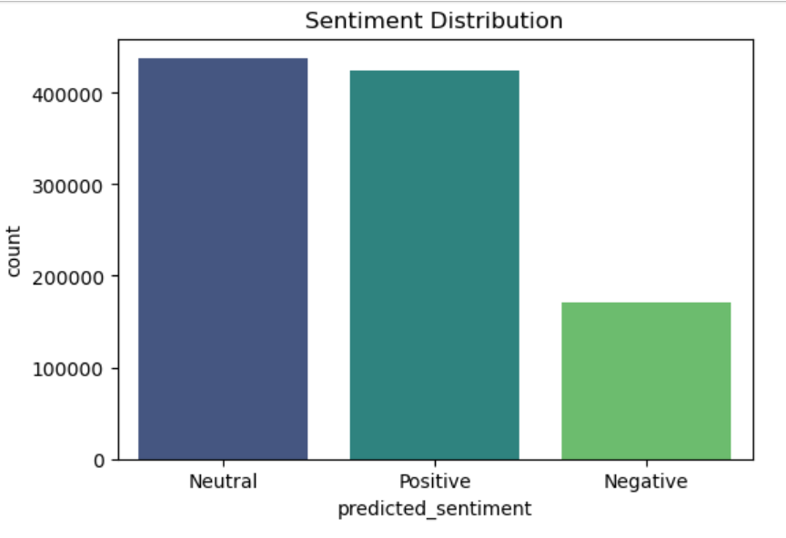

- Positive Sentiment WordCloud

The positive sentiment wordcloud displays the most frequently used words in comments classified as positive. Words such as good, great, love, and excellent appear prominently, showing user appreciation and satisfaction. These terms indicate positive experiences and supportive feedback toward the content. The visualization makes it easy to identify key themes driving positive reactions. Overall, it highlights strengths perceived by the audience.

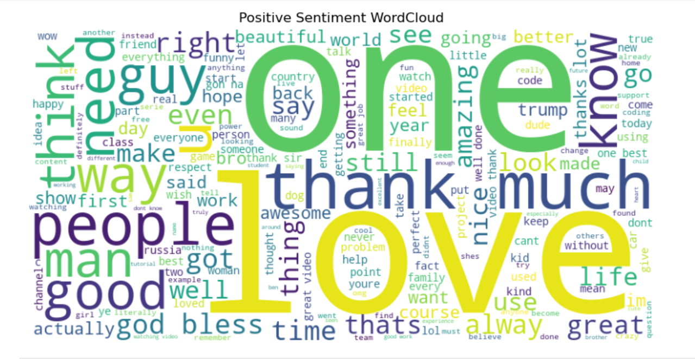

- Negative Sentiment WordCloud

The negative sentiment wordcloud represents common words found in negative comments. Frequently appearing terms like bad, worst, problem, and issue indicate dissatisfaction or criticism. These words point to specific concerns or negative experiences shared by users. This visualization helps identify problem areas that may require attention or improvement. It provides insights into recurring negative themes within user feedback.

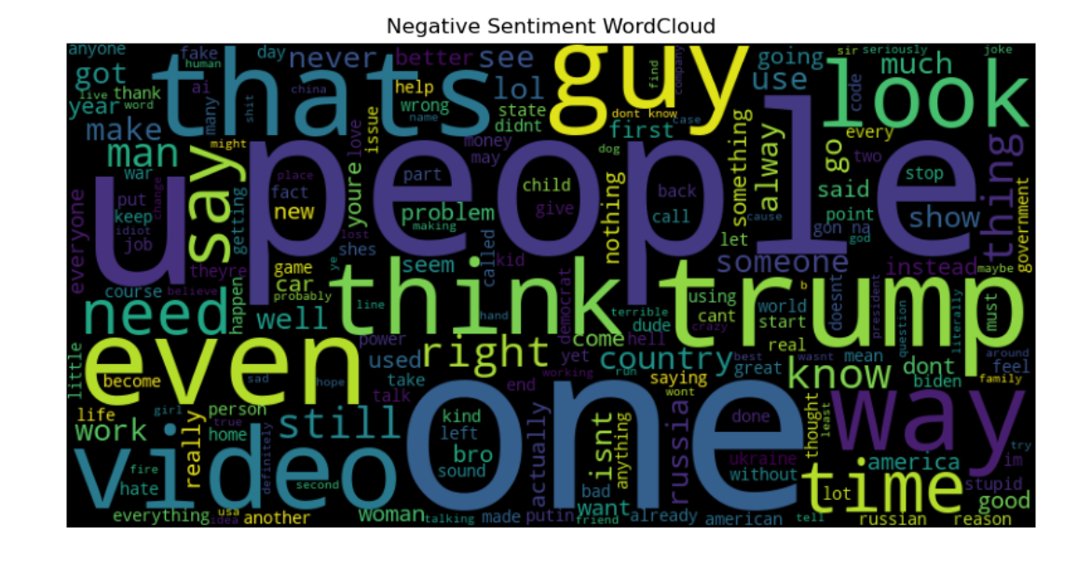
- Sentiment Trend Over Time

The sentiment trend over time visualization shows how user sentiment changes across different time periods. An increasing trend in comment volume indicates growing user engagement over time. Fluctuations in positive and negative sentiments suggest periods of higher satisfaction or criticism. This trend analysis helps track audience reaction patterns. Overall, it provides a temporal understanding of sentiment dynamics.

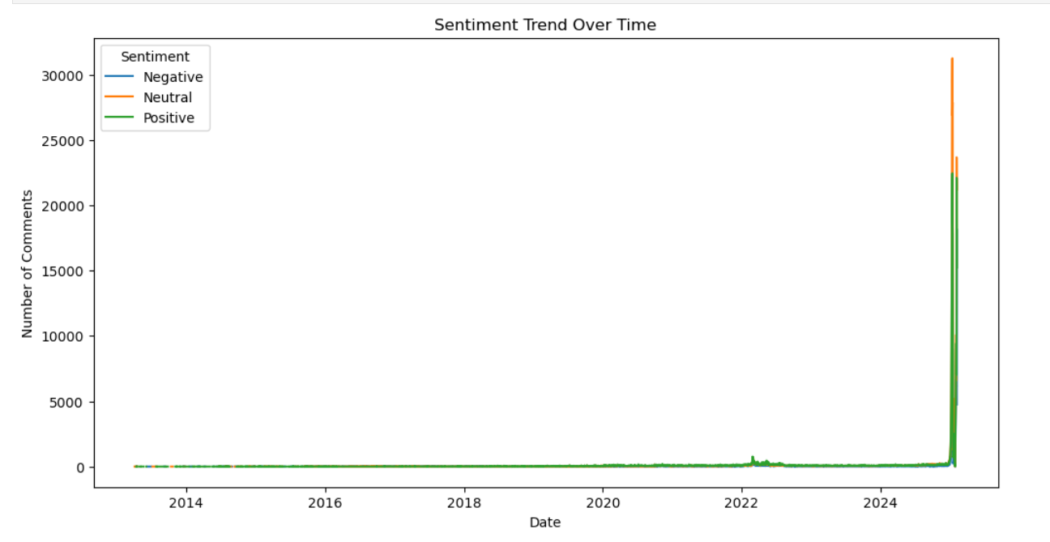
PROJECT INSIGHTS
- The analysis reveals that neutral sentiment dominates the dataset, indicating that most users engage with content in an informational or non-emotional manner rather than expressing strong opinions.
- Positive comments outnumber negative ones, suggesting an overall favorable audience response toward the video content. This reflects good content acceptance and viewer satisfaction.
- The positive sentiment wordcloud highlights appreciation-related keywords, showing that users frequently express approval, enjoyment, and support in their feedback.
- The negative sentiment wordcloud uncovers recurring complaint-related terms, helping identify areas where users experience dissatisfaction or unmet expectations.
- The sentiment trend over time shows fluctuations in audience emotions, often corresponding to changes in content type, upload timing, or external events influencing viewer perception.
- Overall, sentiment analysis proves effective in understanding viewer engagement, emotional response, and content impact, providing valuable insights for improving content strategy and audience satisfaction.

SUGGESTIONS
- Content creators should focus on increasing positive engagement by analyzing frequently used positive keywords and incorporating similar themes in future content.
- Negative sentiment comments should be reviewed carefully to identify recurring issues, such as content quality, clarity, or relevance, and corrective actions should be taken accordingly.
- Monitoring sentiment trends over time can help predict audience reactions and adjust content strategies proactively during periods of declining sentiment.
- Combining sentiment analysis with engagement metrics like likes and replies can provide deeper insights into how emotional responses influence user interaction.
- Future analysis can be enhanced by using advanced NLP models to improve sentiment classification accuracy, especially for sarcasm and mixed-emotion comments.
- Regular sentiment analysis should be conducted to continuously track audience feedback and improve overall content performance and viewer satisfaction.

CONCLUSION
This project successfully analyzed user comments to understand overall public sentiment using sentiment analysis techniques. The visualizations, including sentiment distribution, word clouds, and sentiment trends over time, provided clear insights into audience opinions and emotional patterns. Positive and negative word clouds highlighted the most frequently used terms, helping identify key factors influencing user reactions. The sentiment trend analysis revealed how audience sentiment changes over time, indicating periods of increased positivity or negativity. Overall, this analysis demonstrates the effectiveness of sentiment analysis and data visualization in extracting meaningful insights from large volumes of textual data and supporting better decision-making.

